Overview
- ARSTOW’s account for 17.75% of all GEN11 faulted time, with jams accounting for 48.32% of faults and 74.64% of overall downtime hours. RME iDEA and AE completed at deep dive, identifying the upper and lower over travel limit switches, home proximity switch and carriage interface demonstrated variance by machine, allowing carriage gap variance on the upper and lower infeed's, leading to “lift jams”
- ARSAW’s account for 9.34% of all GEN11 faulted time, with jams accounting for 28.10% of faults and 42.10% of overall downtime hours. RME iDEA and AE completed at deep dive, identifying ARSAW’s suffer from the same condition with carriage alignment as ARSTOW.
- The adjustments to the mechanical setup of these ARSAW and ARSTOW stations will provide an optimized alignment of totes entering and exiting, resulting in higher system reliability.

Precautionary Note
- These modifications will require an RME technician, requiring a PTP and workorder to be completed prior to implementing changes.
- While adjusting the home positions of the tote lift, technicians will be exposed to a “Gravity” hazard if the machine is de-energized. Appropriate blocking will be required for the safety of the technician/s.
- This procedure has been written for a competent Controls/MHE Technician to follow and assumes the technician possesses a reasonable level of knowledge and the ability to use basic hand tools.

Required Tools
- Tape Measure – ASIN B07QG3ZXQC (example only) Link
- Machinist Square – ASIN B084H232QS (example only) Link
- Metric Allen Pack – ASIN B004VMR6ZK (example only) Link
- Metric Wrenches or Socket Set – ASIN B0B8TR3WDL (example only) Link
- Level (minimum length of 2 foot) – ASIN B07G2DLXKL (example only) Link

Calibrating the “Tote Lift”
- Obtain required tooling mentioned on page #1
- Complete PTP via the EAM / APM workorder and ensure the work area is safe
- Utilizing the Dematic HMI, log into the station (login button shown below) with password “1234”
  - 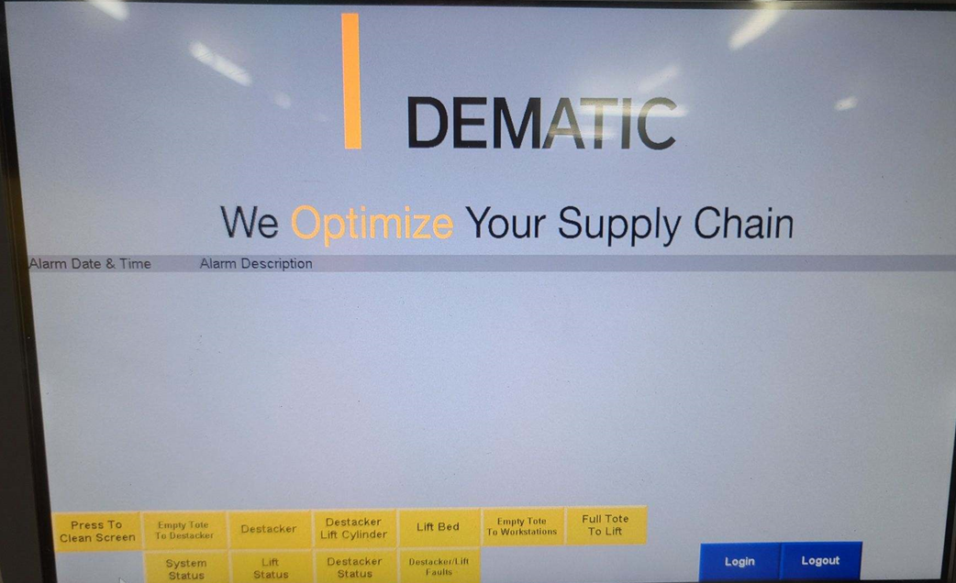

- Utilizing the Dematic HMI, log into “Train Lift Positions” (button shown below)
  - 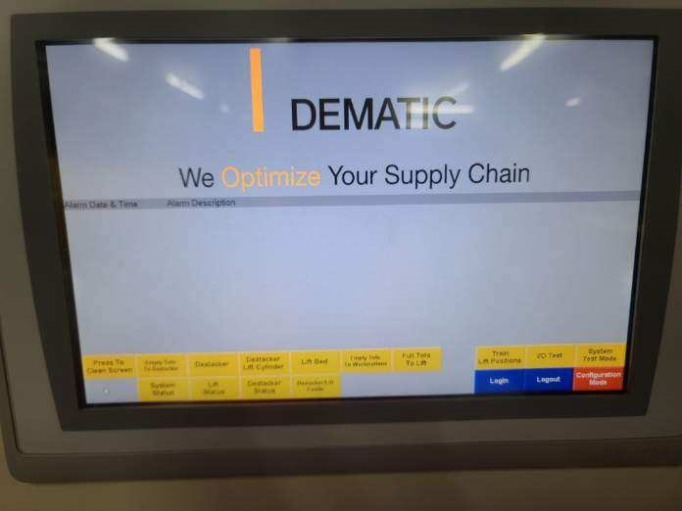

- This screen will be utilized to calibrate Position 1 “Empty Tote Enter”, Position 2 “Full Tote Enter”, Position 3 “Empty Tote Exit” and Position 4 “Full Tote Exit”.
  - 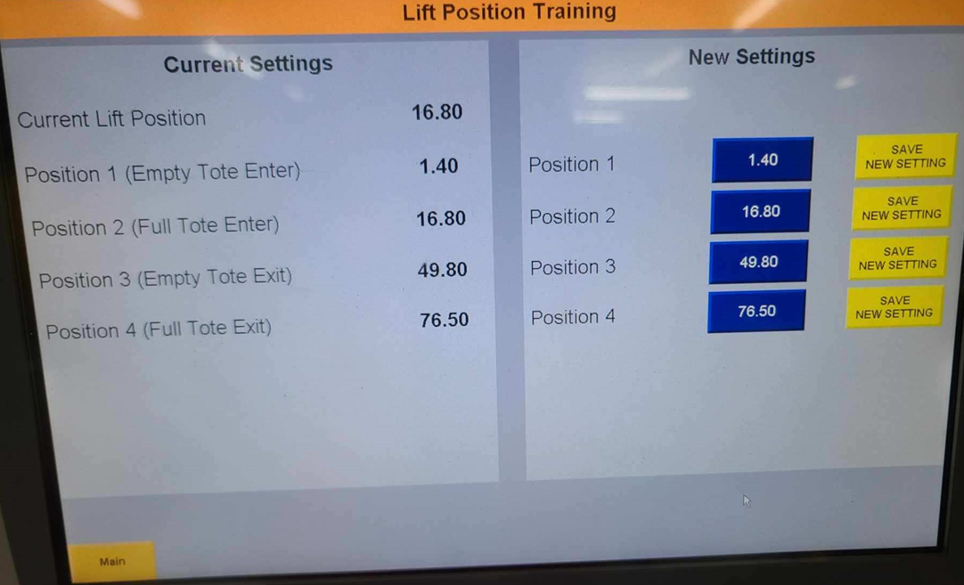
- Jog lift conveyor to position 1
- When the lift conveyor is in position, request access and open the door.
- Place a level across the top of the rollers on the lift conveyor and the interfacing conveyor.
  - ** Important ** The level must be halfway on each platform to ensure an accurate reading.
- Adjust the setpoints as needed until the two platforms are completely level via the HMI
- Save the new settings via the appropriate level push button.
- Repeat the prior steps for each position until all are calibrated appropriately.

